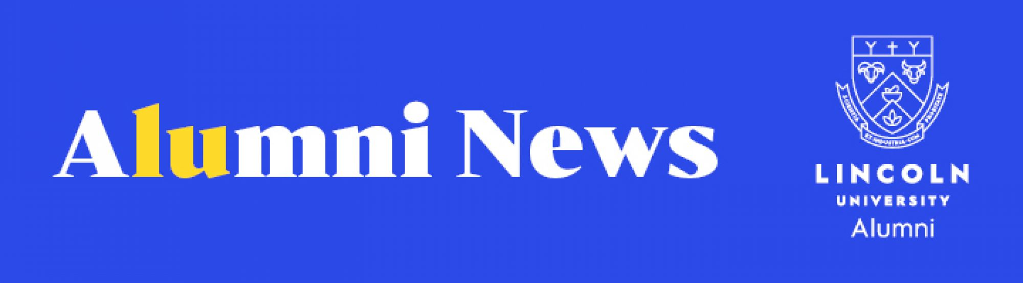
Welcome to the October edition of Alumni News. We have some great stories about our newest graduates, a review of alumni events, and updates on the exciting research happening at Lincoln.
We're also excited to be counting down to our first ever 24-hour Giving Day on Thursday 27 October. Together, we can support the next generation in finding solutions to some of the world's most pressing land-based challenges. We hope you will join us.
Alumni and Development Team

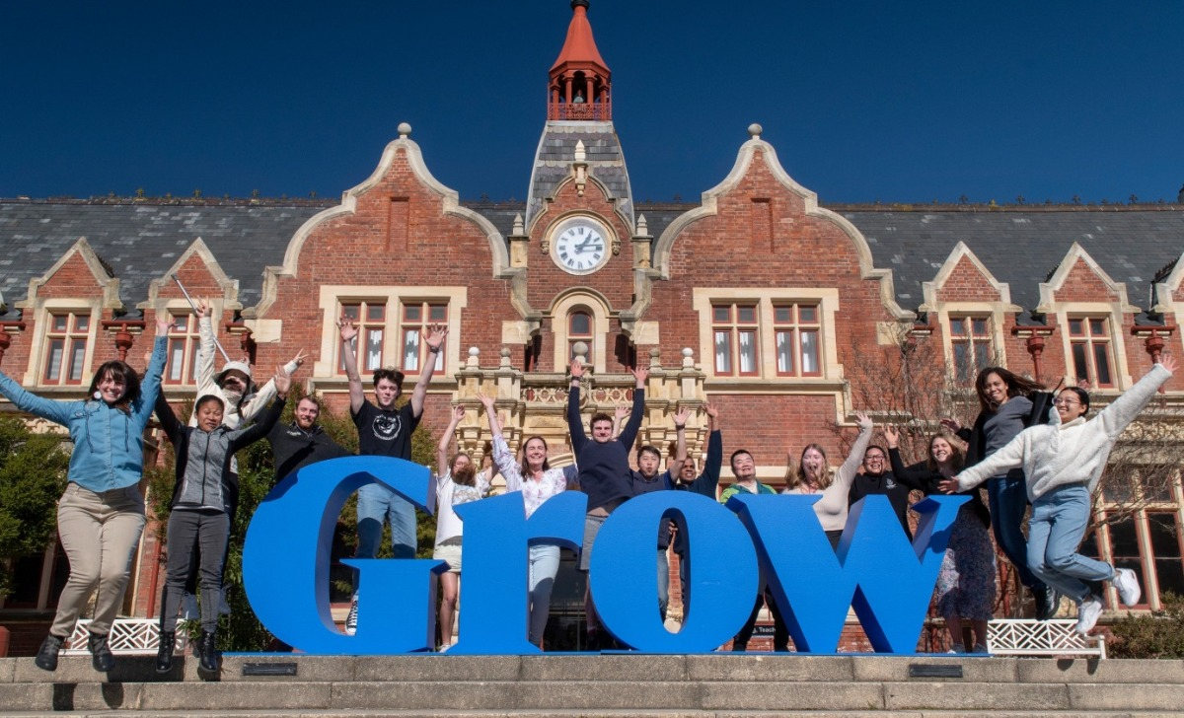

New date for Giving Day, Thursday 27 October
Grow our students. Grow the future.
The date for Lincoln University's Giving Day has been rescheduled to Thursday 27 October.
We are inviting our entire Lincoln community, past and present, to come together and support our next generation of students to help grow a better future. Together, we can support the next generation in finding solutions to some of the world's most pressing land-based challenges.
All donations will be doubled thanks to our generous matching donors who have already pledged their support. For more information, download the Giving Day brochure and Donation Form, email alumni@lincoln.ac.nz, or visit https://www.charidy.com/LincolnUniversity.

Celebrating our alumni


Georgia has the Rugby World Cup on her mind
Black Fern Georgia Ponsonby's rugby journey led her to Lincoln, where her sporting career took off with a Sports Scholarship, and she began another in rural valuation. Georgia attended our recent Graduation Celebration... read more

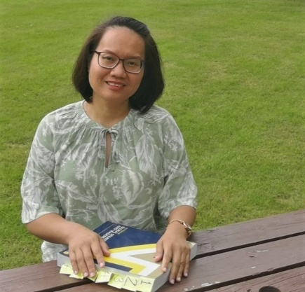
Job offer a good result for Gemma
Gemma Austria had a job offer the same day she received the results for her final paper. She passed her Master of Professional Accounting (CPA) degree in November to graduate this year... read more

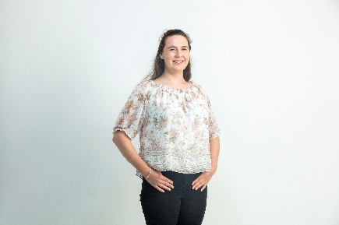
Environmental graduate makes her mark on campus
Graduate Amy Wells is continuing her studies to help reduce the environmental impact of agriculture. "I want to work with farmers to help them navigate environmental regulations and reduce their impacts," she said... read more

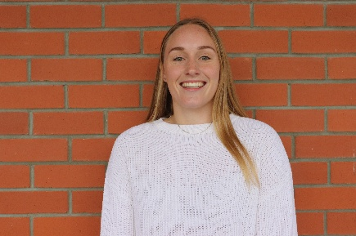
LU helps Natasha smash career and sporting goals
Carrying out practical work at Novo Group as part of her degree proved fruitful for new graduate Natasha Ryan, who became a full-time landscape architect there after completing her studies... read more


Great gift idea for graduates
Graduated this year (or know someone who has) and want to mark the occasion with all the bells and whistles? The graduation commemoration whistle is a great gift for yourself or a friend, and is engraved with the graduate's qualification and final year of study. It's available until 10 October so order now.

University news

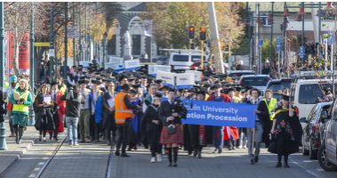
Distinguished contributions recognised at Graduation Celebration
High-profile scientists and chief executives were among the recipients of honorary awards from Lincoln University at the Graduation Celebration in the Christchurch Town Hall... read more

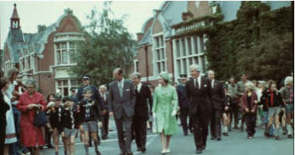
Royal Memories from our Alumni
Following the passing of Queen Elizabeth II, Lincoln alumni, Dr Margaret Evans and Bert Eastoe, recall their personal meetings with the Queen during her campus visit 45 years ago... read more

Growing the future

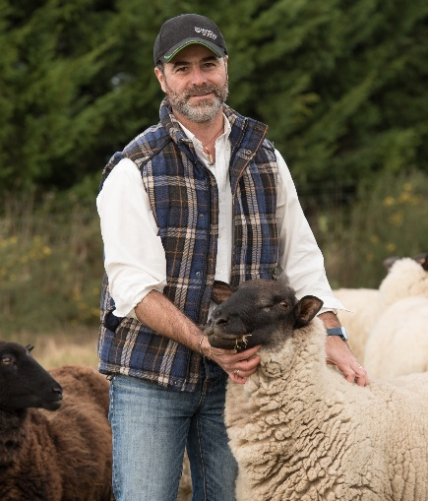
Professor points the way to paradigm shift in pastoral production
Lincoln University Professor Pablo Gregorini says a paradigm shift is needed to create a more ethical, sustainable pastoral production system... read more

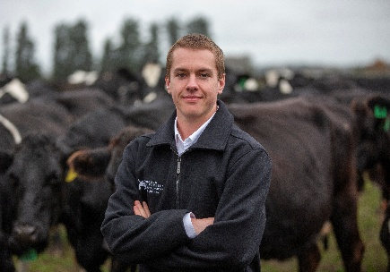
Taking stock of the evidence for more climate-friendly cows
Recent PhD graduate Dr Cameron Marshall's research shows that some cows are genetically predisposed to cause less harm to the environment than others, and farmers can potentially use the findings to breed more climate-friendly animals... read more

Giving Back

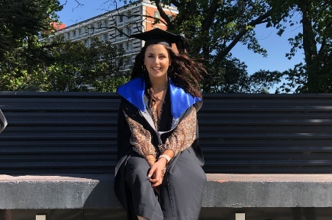
Scholarship helps in fight against pests and plastic
The William Machin Doctoral Scholarship for Excellence is helping Katie Pitt find ways to stop adding to one problem while combating another. The PhD student is researching how to create biodegradable pest mammal monitoring products... read more

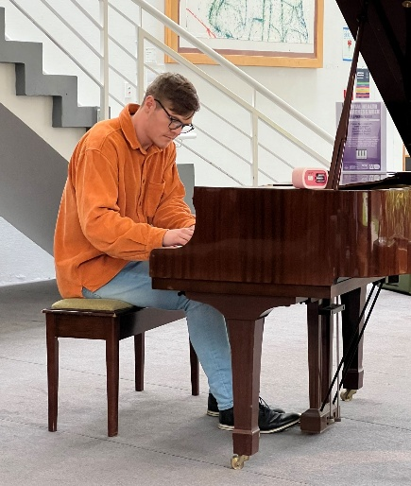
Alumnus plays 'Piano for Hope' concert
Lincoln staff and students were treated to a lunchtime concert by alumnus and pianist, Sam Cooper (Bachelor of Environmental Policy and Panning (Hons)), in the Stewart building foyer... read more

Stay Connected

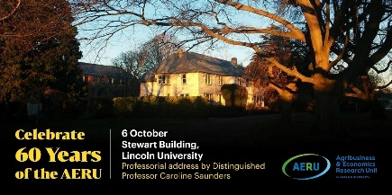
Celebrating AERU's 60th Anniversary
The AERU invites you to celebrate its 60th anniversary in Stewart Foyer or online on Thursday 6 October and hear a professorial address by Distinguished Professor Caroline Saunders. For more information or to register, visit here.

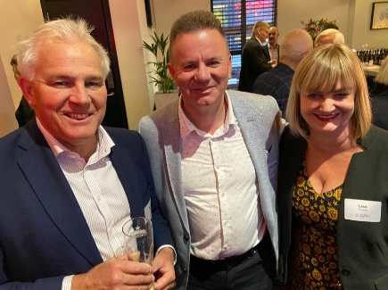
Auckland Alumni enjoy LincUp Event
More than 50 Lincoln alumni gathered at the Harbourside Ocean Bar at the Auckland waterfront on Wednesday 7 September for a catch-up and the opportunity to hear from Lincoln's new Deputy Vice-Chancellor Student Life, Damian Lodge, on the latest news from the university... read more

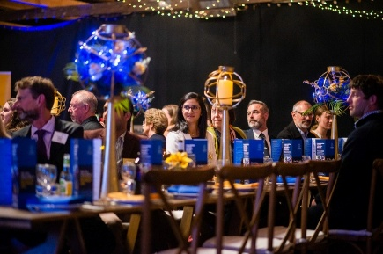
Vice-Chancellor's Invitational PhD Dinner
Lincoln University's 2022 PhD graduates, along with friends and family, had a very special evening at Larcomb Vineyard in Rolleston last week to celebrate their academic achievements... read more

Save the Date

6 October
The AERU's 60th Anniversary
Stewart Building, Lincoln University or online
Learn more here
17-19 October
BAgrSc 1970 Reunion
Christchurch/Lincoln Organisers:
Chris Mortlock and Andy Bray
25 October
Tuesday Lunch Club
Duvauchelle
26 October
NZIAHS Canterbury Forum - Can New Zealand Farmers Mitigate Climate Change?
Lincoln University
Learn more here
27 October
Lincoln University Giving Day
Lincoln University
For more information, please email alumni@lincoln.ac.nz
4 November
Melbourne Alumni Annual Dinner
Melbourne City
8 November
Hawke's Bay Alumni event
Hawke's Bay
9 November
Wellington Alumni (after 5pm) event
Wellington
24 November
Wellington Christmas Luncheon
Wellington Club
24 - 26 March 2023
1983 BAgrSc and BHortSc Reunion
Christchurch/Lincoln
Organisers: Mary Duncan, Pete Moynihan
29 - 31 March 2023
BAgrSc and BAgCom Class Reunion, (started in 1972 & 1973)
Organisers: Alistair Wing, Mark Lemon
Methven
30 March - 1 April 2023
BAgrSc 1968 Reunion
Chirstchurch/Lincoln
Organisers: Athol McCully, Marg Evans, Paul Jarman
31 March - 3 April 2023
1972 - 74 DipAg & VFM Reunion, 50th Anniversary
Christchurch/Lincoln
Key organiser: Bernard Duncan
28 April 2023
1963 BAgrSc Reunion
Christchurch/Lincoln
Organiser: Allan Frazer

Obituaries

Lincoln University acknowledges with respect the passing of the following alumni and supporters:
Michael (Mike) Guthrie Bradley (DipAg, 1962, Dip VFM, 1963), Christchurch, 19 September 2022, aged 82
Catherine Margaret Haddock (MAPP, 1998), Lower Hutt, 10 September 2022, aged 65
Trevor William Kitchin (BCom Ag, 1982), Napier, 10 September 2022, aged 63
Peter Stevenson Little (RFC, 1962; Dip Ag, 1966; Dip VFM, 1967), Carterton, 30 August 2022, aged 78
Munro McLennan (BAgSc, 1970), Havelock North, 12 September 2022, aged 74
Derek Edwin Snow (Cert Ag 1963; Dip VFM 1966), Hastings, 22 September 2022, aged 79

  More news
  Events calendar
  Update your details
  Give to scholarships

Do you have a story to share? Are there topics you'd like us to cover in this publication? We'd love to hear from you. Please contact us at alumni@lincoln.ac.nz.



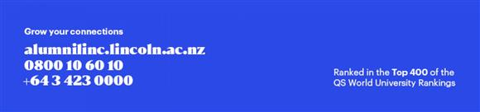

Georgia has the Rugby World Cup on her mind
Wednesday, 21 September 2022

Black Fern Georgia Ponsonby’s rugby journey led her to Lincoln, where her sporting career took off with a Sports Scholarship, and she began another in rural valuation.
Georgia will be at the Lincoln University Graduation Celebration on 23 September to don regalia and be congratulated on achieving her Bachelor of Land and Property Management degree in front of friends and family.
She has the Rugby World Cup in her sights, which will be played in New Zealand next month, but has also secured a place in the ASB FutureMe Rural Banking Grad programme. She fits that in on a Wednesday, her only day off from training with the Black Ferns (as she is on a full-time contract).

"My aspirations are to win a world cup on home soil, to have a long and prosperous career in the black jersey, to be a rural manager for ASB and to one day get my valuation certificate," she said.
She grew up on a sheep and beef high country station near Taihape in the Central North Island, and was drawn south because of the sporting opportunities.
"I boarded at Feilding High School before deciding to come down to Lincoln purely because one of my friends told me I should.
"Uni didn't really interest me until then but I applied for the Lincoln rugby scholarship and got it, which helped me make up my mind.
"I wanted to be involved in the ag industry but had no idea what I wanted to study so started off doing a Bachelor of Commerce (Agriculture) degree but after the first semester, decided valuation interested me and so switched to a Bachelor of Land and Property Management with a Rural Valuation major.”
Georgia, a front rower, debuted for Manawatū in the Farah Palmer Cup in 2017, while still at school.
When she came Lincoln she joined the Canterbury team, impressing the national selectors, and making her Black Ferns off the bench against France in Pau in 2021.


Job offer a good result for Gemma
Tuesday, 27 September 2022

Gemma Austria had a job offer the same day she received the results for her final paper.

She passed her Master of Professional Accounting (CPA) degree in November to graduate this year, and took on the external auditor job.
Three months later, she was promoted to senior auditor.
From the Philippines, she chose the programme at Lincoln as it was "relevant to my undergraduate degree of the Bachelor of Science in Accountancy, and work experience as an auditor and accountant".
Gemma enjoyed the online aspect of the programme.
"It worked best for me because as a full-time student while working part-time, it gave me flexibility and saved money and time to travel from Hornby to Lincoln."
The skills she learned at Lincoln have been crucial in her new role.
"The up-to-date concepts in accounting, auditing, tax, financial risk management (derivatives) helped me in my audit risk assessment, analysis, and decision-making.”
She even found the job through the CPA network from a friend and said she has easily adjusted to work in New Zealand.
"New Zealand is peaceful, with much freedom, a sense of equality and privacy, and has beautiful nature."
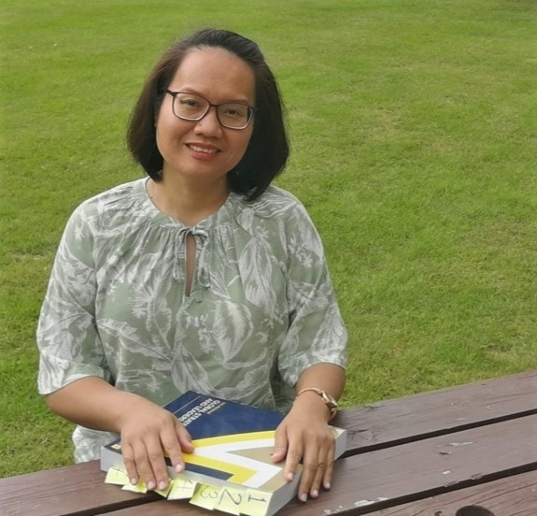

Environmental graduate makes her mark on campus
Tuesday, 27 September 2022
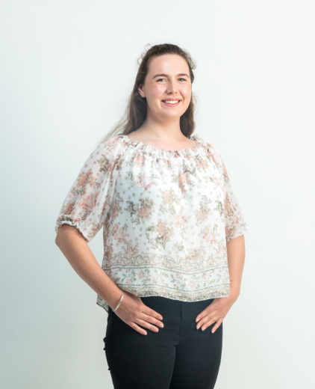
Graduate Amy Wells is continuing her studies to help reduce the environmental impact of agriculture.
However, she is leaving her own impact on Lincoln.
She graduated this year with a Bachelor of Science (Environmental Science) but has stayed on to complete her Honours degree.
"I want to work with farmers to help them navigate environmental regulations and reduce their impacts," she said.
Amy is a Future Leader Scholar, has a DairyNZ Scholarship and a JMH Tripp Agricultural Scholarship on her resume, and recently received the Southern Environmental Trust Scholarship.
She has also won a Gold Award from Lincoln, in recognition of her work in the community and on campus.
Amy was a co-founder of the Lincoln Student Volunteer Army, as well as a campus class representative, Vice-President of the Soil Society and a leader for Lincoln Brownies.
"Coming from a dairy farm, Lincoln’s land-based focus appealed.
"I’ve enjoyed being able to link what we learn to the real world and learning about industry-leading research. The Future Leader program is unparalleled and I’m grateful for the opportunities and support I’ve received from it.
"Highlights of my time at Lincoln have included the many friends I’ve made and establishing a Student Volunteer Army Club.
"Another highlight has been being a leader for Lincoln Brownies.
"It’s been cool to share my knowledge from classes like ecology and the girls loved visiting the university for bouldering and bike safety."

LU helps Natasha smash career and sporting goals
Wednesday, 21 September 2022

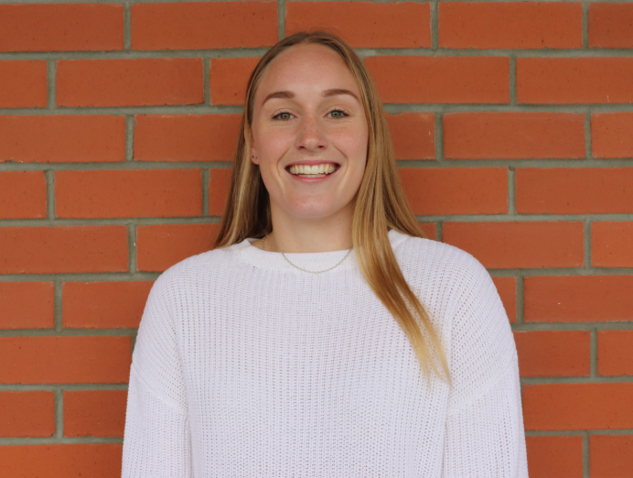Carrying out practical work at Novo Group as part of her degree proved fruitful for new graduate Natasha Ryan, who became a full-time landscape architect there after completing her studies.
In addition to kick-starting her professional career with a Bachelor of Landscape Architecture, Natasha took part in Lincoln’s renowned Sports Scholarship Programme, reaching great heights in netball.
She enjoyed stunning success on the court, winning an individual Blues Award for Sporting Excellence in 2021 and being part of the LU Premier Netball Team that scooped Team of the Year for taking out the Christchurch Netball Centre Premier Division.
Her involvement across a wide range of activities on campus gave Natasha the chance to meet a wide range of people "and make lifelong friends along the way, whether it was through my course, the Halls of Residence, sports teams or the LU Gym".
She said studying at Lincoln prepared her for a professional career by offering hands-on experience, introducing her to potential employers and giving her the chance to network with businesses around Christchurch.
"One aspect of my studies that I enjoyed the most was being exposed to a variety of lecturers, tutors and professionals with a wide range of experiences and valuable information.
"I also enjoyed working towards my Major Design Project, which was based on Otamahua/Quail Island. Being able to learn about the rich historical and ecological heritage of the island was thoroughly enjoyable."
Natasha was at the Lincoln University Graduation Celebration in the Christchurch Town Hall on 23 September to mark her academic achievements.
Although she already received her qualification earlier this year, the ceremony was organised to acknowledge the hard work of Lincoln’s 2022 graduates, following the cancellation of the original ceremony in May due to COVID-19 restrictions.
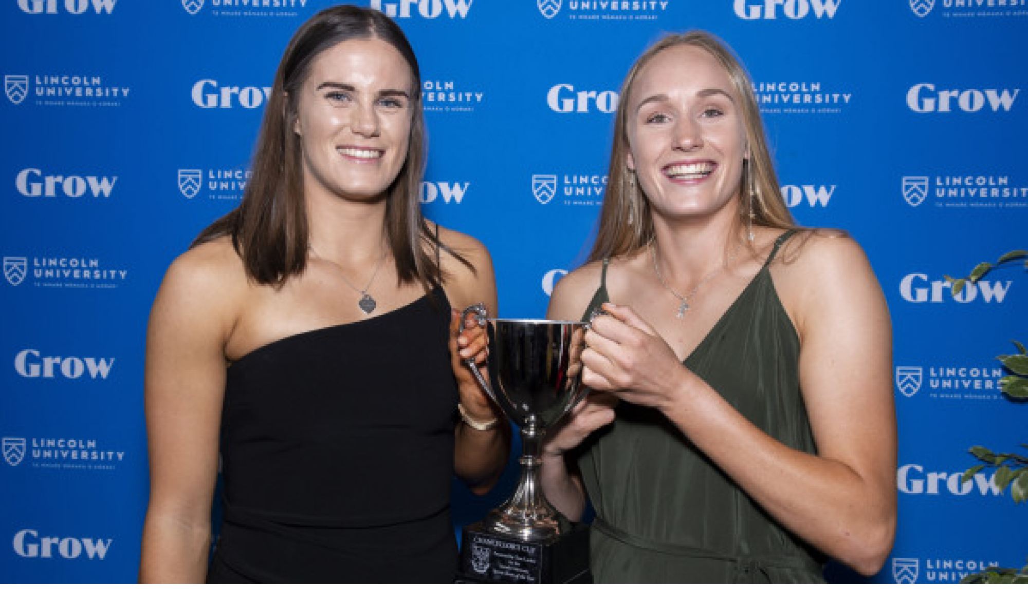
Natasha Ryan (right) with 2021 LU Premier Netball Team captain, Laura Dorgan, at last year's Blue and Gold Awards.

Distinguished contributions to be recognised at Graduation Celebration
Wednesday, 21 September 2022
High-profile scientists and chief executives were among the recipients of honorary awards from Lincoln University at the Graduation Celebration in the Christchurch Town Hall.
Commonwealth Games Federation CEO Katie Sadleir received the Lincoln Alumni International Medal at the ceremony, while The Right Honourable Sir David Carter, a former Speaker of the House of Representatives, animal geneticist Philip Beatson, Barker Fruit Processors Ltd head Michael Barker, educator Helen Sherpa and conservationist Dr Lhakpa Norbu Sherpa were also 2022 awardees.
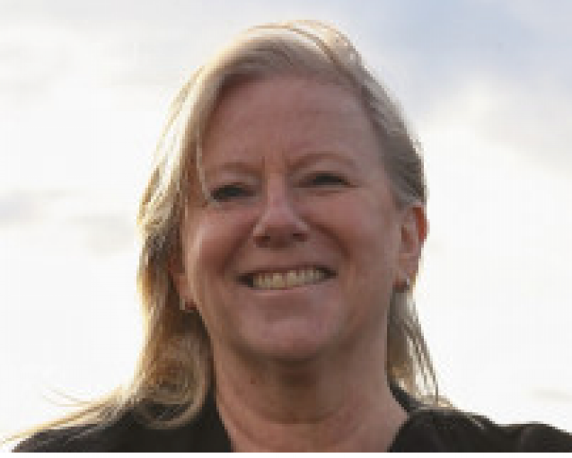
Professor Bruce Scoggins was recognised posthumously at the ceremony.

Catherine (Katie) Sadleir
Lincoln Alumni International Medal
Katie Sadleir’s high-profile career has seen her hold several ground-breaking roles in New Zealand high performance sport, before becoming the world’s first general manager of women’s rugby and her recent appointment as the first female Chief Executive Officer of The Commonwealth Games Federation in the United Kingdom.

Since she graduated with a Diploma in Parks and Recreation Management from Lincoln University in 1990, she has worked in pivotal leadership roles in the sport and recreation sector.
Katie led the establishment of the New Zealand Academy of Sport network in the late 1990s and drove the need for the implementation of high-performance coaching and leadership to ensure New Zealand would be competitive on the world stage.
She went on to be a Director of HSPNZ and of Sport NZ.
In 2017 she was appointed General Manager Women’s Rugby at World Rugby based in Dublin, Ireland, and was responsible for developing women’s rugby globally, a challenge in a traditionally male-dominated arena, and she succeeded in growing the game in non-traditional rugby nations.
In her current role, Katie plays a leading role in driving the future strategic direction of the organisation and she wants to ensure the global sporting movement is fully focused on community legacy, benefit, and impact through sport.
She has a strong sporting pedigree and is a 1986 Commonwealth Games bronze medalist in synchronised swimming, and competed in the 1984 Olympics in Los Angeles.
She was Assistant Chef de Mission for the New Zealand team at the 1994 Commonwealth Games in Victoria and was given the Lifetime Achievement Award at the 2016 New Zealand Sport and Recreation Awards, being cited as the architect of many of the systems and programmes fundamental to the high-performance sport system in New Zealand today.
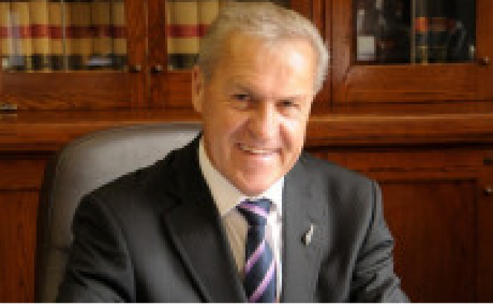

The Right Honourable Sir David Carter
Honorary Doctorate of Commerce honoris causa
The Right Honourable Sir David Carter has had a long and distinguished political career and is a former Speaker of the House of Representatives.
An alumnus of Lincoln University, graduating with a Bachelor of Agricultural Science in 1974, he was a Member of Parliament from 1994 to 2020 and in that period fulfilled the roles of Minister of Agriculture, Minister for Biosecurity, Minister for Forestry, and Minister for Primary Industries.
He was also Associate Minister of Education and has always had a close interest in education.
He is a great advocate for the use and application of science in agriculture and an advocate and ambassador for Lincoln University, encouraging its inclusion in conversations relating to the primary industries.
He has acted as a link between the University and Parliament and as Minister of Agriculture, Sir David officially opened the Lincoln University-based National Centre for Nitrous Oxide Measurement, a highly significant national facility for the measurement of greenhouse gases.
During his final years in Parliament he was New Zealand’s permanent representative at the Inter-Parliamentary Union (IPU) and an active member of the IPU Committee on the Human Rights of Parliamentarians.
In 2021, he was knighted in recognition of his distinguished public service.
Whilst Minister of Agriculture he focused on improvements to biosecurity, the importance of science in the future of agriculture, and the importance of New Zealand’s international reputation as a producer and exporter of quality foods.

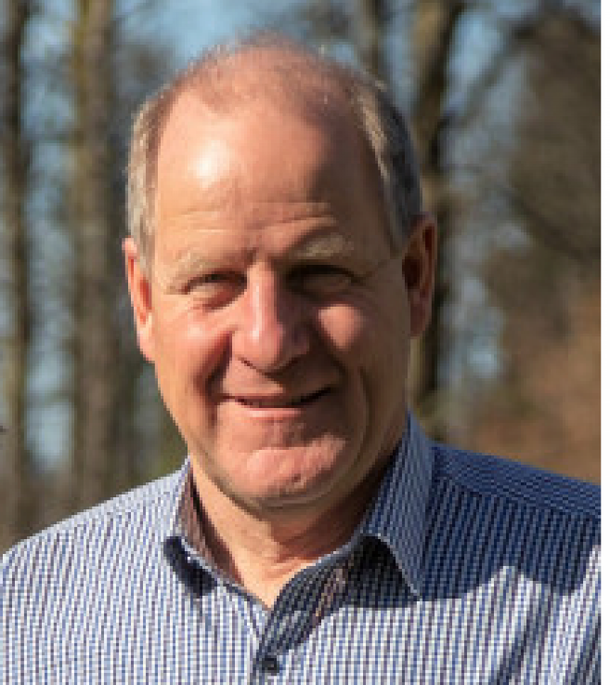
Michael Barker
Bledisloe Medal
Michael Barker has made an outstanding contribution to the fields of business, marketing, manufacturing and horticulture in New Zealand and internationally.
As CEO and Chairman of Barker Fruit Processors Ltd, he developed a small family fruit winemaking business into a nationally recognisable icon and business, making world class jams, chutneys, syrups, and condiments. Barker’s now employs over 270 people and has become market leader in multiple categories. Anathoth Preserves joined the business in 2007 and all manufacturing takes place near Geraldine on a corner of the old family farm, making over 600 products from more than 1000 ingredients.
He obtained a Bachelor of Horticultural Science degree from Lincoln University in 1980. He approached his Lincoln marketing lecturer, Michael Mellon, and asked for help to create a business plan for Barker’s. Together, Mellon and Barker developed a business strategy beginning with locally pressed blackcurrant juice that led Barker’s to become, firstly a New Zealand, and then Australasian leader in processing fruit into grocery, bakery, foodservice and ingredient products. It has won numerous food industry and business innovation awards. His strategy was always to innovate to create great tasting foods and food solutions.
In 2019 he opened a Geraldine site for the new Barker’s Foodstore and Eatery and developed the former Anglican vicarage for boutique accommodation. Speaking at Barker’s 50th anniversary celebrations via video message, New Zealand Prime Minister Jacinda Adern and French ambassador Sylvaine Carta-Le Vert both commented on Michael Barker’s innovation, ingenuity and hard work as being keys to the business’ success.

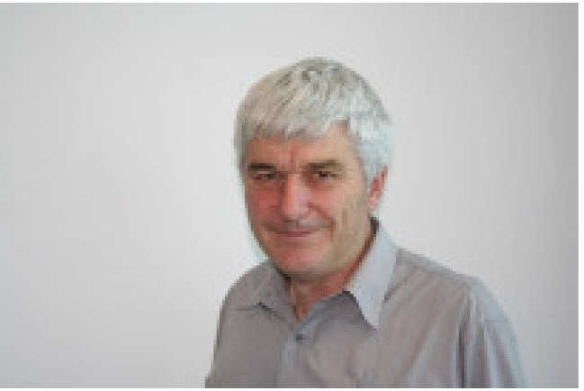
Philip Beatson
Honorary Doctor of Science honoris causa
Philip Beatson’s strong commitment to the science of genetics and animal breeding has led to success in the commercial world, but he has always maintained a close contact with Lincoln University.
As Research and Development Manager for CRV Ltd he held the view that application of genetics enables ongoing and socially-acceptable means of improving productivity. His vision of dairy cows living longer, having better functional traits with higher milk yields and ability to get back in calf on an annual basis led to him developing the NZ Merit Index.
His innovative thinking has led to numerous CRV initiatives addressing climate change and sustainability. He recognised the relationship between milk urea nitrogen concentration and urinary nitrogen output and years of on-going research with industry partners, including Lincoln University, has led to the availability of ‘LowN’ genetics.
His knowledge of sheep breeding technologies enabled CRV to breed bulls whose offspring are more facial eczema tolerant, and he has developed teams of bulls which will breed polled offspring.
He recently led CRV cooperation with Livestock Improvement Corporation to identify low methane emitting young bulls with the aim of reducing greenhouse gas emissions from dairy cattle.
He graduated Bachelor of Agricultural Science (Honours) from Lincoln in 1974 and returned in 1980 holding the position of Lecturer in Animal Breeding from 1981 to 1997.
In this role he was a member of a team which constructed a widely adopted breeding index which increased lean growth in lambs; he designed the genetic engine for Flocklinc, a national database holding sheep performance records; he was instrumental in establishing selected and ‘control’ lines in the University’s Coopworth flock and is now mentoring a Lincoln University group aiming to sequence the genome of this unique genetic resource.

Professor Bruce Scoggins
Honorary Doctor of Science honoris causa
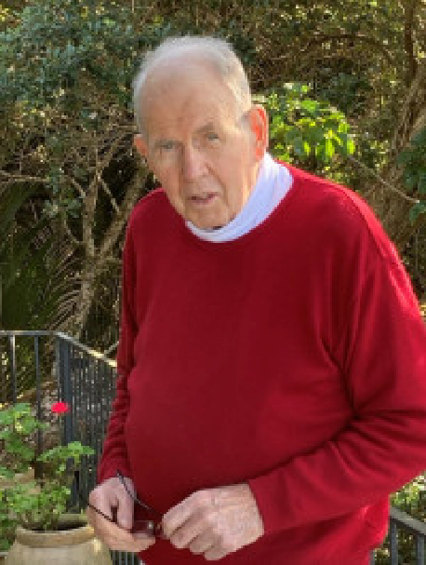
The late Professor Bruce Scoggins, who died in March 2022, had a distinguished career in science and research since 1962 and an ongoing relationship with Lincoln University for over 60 years, evidenced by his award of the 2007 Bledisloe Medal.
He started a Bachelor of Agricultural Science at Lincoln College in 1958 and went on to a Master of Agricultural Science (1st Class Hons) in Wool Science.
Through his leadership of the Health Research Council and Cure Kids he was involved in the award of research grants to support the on-going research into Batten Disease founded by Professor David Palmer and continued by his colleagues at Lincoln.
From 1964 to 1989 he was at the Howard Florey Institute in Melbourne conducting world class physiological research in sheep, looking primarily at the control of salt excretion and regulation of blood pressure.
He spent 1976 as a Senior Fulbright Fellow in Boston and from 1989 to 1991 he was the Gordon Meiklejohn Professor of Medicine at the University of Colorado in Denver.
From 1991 to 2006 he was chief executive of the Health Research Council in NZ, reporting to the Minister of Health and responsible for development and implementation of best practice policies and processes to manage the Government’s investment in health research. During this time he represented New Zealand on the WHO’s Regional Research Committee.
From 2007, he chaired the Medical and Scientific Advisory Committee of Cure Kids. He was a Board member, and was involved in an impact evaluation of 50 years of the charity’s investments in child health research. He also initiated an annual review of the state of child health in New Zealand. His work for the charity was honorary.

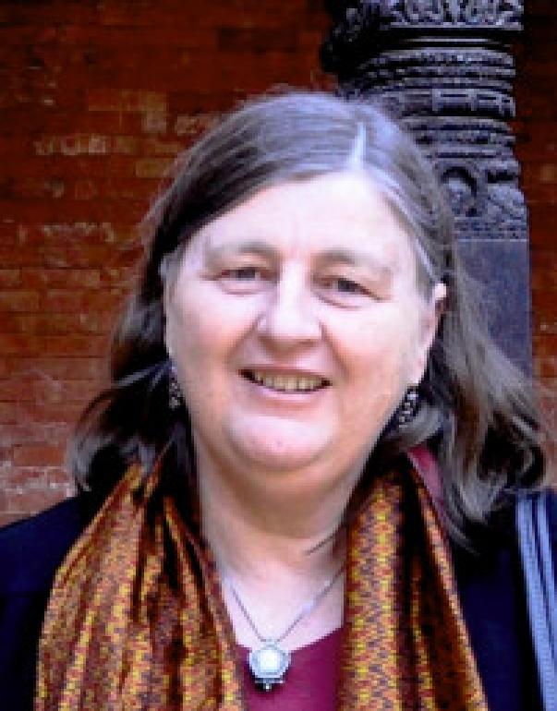
Helen Sherpa
Alumni International Medal
Helen Sherpa has worked for the improvement of education, health and well-being of Nepalese communities disadvantaged by poverty, caste, age or access to services for more than 25 years.
The 1980 Lincoln University Diploma of Parks and Recreation graduate is the Country Director of World Education Inc, and her programmes are aimed at women and children in rural communities. She is highly experienced in the planning, development and management of the delivery of formal and non-formal education services for the poorer and more disadvantaged communities.
Helen has developed cooperative arrangements with local NGOs including the training of their staff, and village facilitators, to implement and sustain programmes and serves as the key liaison person between the NGO, UNICEF, World Food Programme, international donors and the Ministry of Education.
She has led work to develop World Education’s Early Grade Reading, and pre-school learning programmes, and on United States’ funded projects from 2002 to 2013 she led the development of educational in quality non-formal training for children and adults, and works towards improved learning outcomes and equity in education.
Over two decades these have helped remove more than 65,000 children from the worst forms of child labour and commercial sexual exploitation.
She was also involved in the USAID funded conflict-mitigation program, SIWAG, which reached more than 17,000 women in western Nepal with literacy, financial literacy and income generation interventions and played a key role in the development of the “Farmer Field School” approach across Nepal, and the “Schools as Zones of Peace” (SZOP) Program.
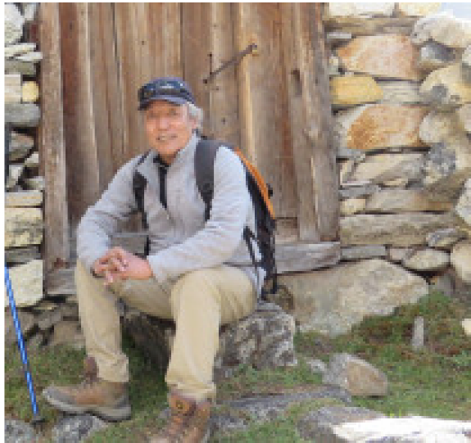
These financial literacy efforts have reached over 150,000 women, and the Farmer Field Schools over 100,000 women farmers, reducing the use of harmful pesticides and increasing productivity.

Dr Lhakpa Norbu Sherpa
Lincoln Alumni International Medal
Dr Lhakpa Norbu Sherpa grew up in a yak farming family in Khumbu near Mt Everest, Nepal. He received the opportunity to have a modern education when Sir Edmund Hillary built a school in his village in 1963. He was then awarded a scholarship to study a Diploma in Parks and Recreation at Lincoln University.
As part of his practical training during his study at Lincoln, he actively participated in the establishment of Sagarmatha National Park in his home region in 1975 and 1976. Upon graduation in 1980 he returned to Nepal, where he joined the National Park Service and served as Chief Warden of a number of Himalayan parks, including Sagarmatha. He eventually also served as the head of Nepal’s Department of National Parks and Wildlife Conservation’s Ecology and Management Division.
While working for the park service, he went on to win internationally recognised scholarships and completed a Master’s and then a PhD in forest resources from the University of Washington, and became the first person from the marginalised Sherpa community to receive a doctorate.
Dr Sherpa has dedicated his career to environmental and cultural conservation in the Himalayas. He worked extensively on the planning and creation of new protected areas and the development of buffer zones. This included the successful establishment of a series of protected areas around Mt. Everest, including the Sagarmatha and Makalu-Barun National Parks of Nepal, and the Qomolangma National Nature Preserve of Tibet (China). These protected areas now secure the world's highest ecosystem.
He joined The Mountain Institute, a US-based conservation organisation in 2000 and worked as an international expert to strengthen the management of the Qomolangma National Nature Preserve on the northern slopes of Mt Everest. From 2005 to 2009 he served as Co-Director of The Mountain Institute's Himalaya Program in Nepal.
He is now a senior community leader, and advisor to local government and organisations. He is also a serious meditation practitioner and teaches and trains young people to promote peace and harmony in individuals and societies.
Congratulations to all the awardees.

Royal Memories from our Alumni
Wednesday, 21 September 2022
As the world mourns the passing of Queen Elizabeth II and reflects on her decades of service, Lincoln University remembers warmly the Monarch’s visit to the campus 45 years ago. Here, two of Lincoln’s alumni, Dr Margaret Evans (BAgrSc Hons 1972, PhD 1977) and Bert Eastoe (DipAgr 1976, DipFarmMgmt 1977), recall their personal meetings with the Queen on her campus visit.
Queen Elizabeth was in New Zealand in 1977 in the course of her Silver Jubilee Tour of Commonwealth countries, and a Royal Visit to the Lincoln campus was seen as a perfect early event for the year-long series of activities leading up to Lincoln’s centenary in 1978.
An invitation was duly despatched, and accepted, and the Royal Visit to Lincoln College took place on Friday 4 March 1977 as part of the Queen’s Civic Visit to Christchurch. Her Majesty was accompanied by the Duke of Edinburgh and hosted on the campus by the Chair of the College Council, Donald Bain, and the College Principal, Professor James Stewart. Also in the official party were the Mayor of Christchurch, Hamish Hay, and the Prime Minister of New Zealand, Robert Muldoon.
Members of the public from Lincoln township and surrounding areas flocked to the campus, joining staff and students to welcome the Royal couple. The Queen and Duke arrived first at the main entrance to the Hilgendorf Building, and after ascending the steps they were introduced to the Student President, Bert Eastoe, who in turn introduced them to a group of students, including Colombo Plan scholars. Inside Hilgendorf the Queen and Duke saw displays illustrating sheep research, then inspected one on equine physiology, prepared by Dr Margaret Evans and Professor Cliff Irvine.
From Hilgendorf they went to the College Library (at that time located in the Forbes Building) to see further displays on current College activities, explained to them by Professor Paul Mulcock and other staff members.
From the Library they crossed to The Lodge, home of the College Principal, Professor James Stewart and wife Nancy. At The Lodge they had a brief rest before crossing the campus to Gillespie Hall and a Civic Luncheon. The Lodge visit is well remembered by Nancy Stewart (later Lady Stewart), who tells the story of a small makeup purse being accidentally left behind by the Queen. Inside it was some very British brand makeup.

In the Hilgendorf Building, where the visit started, Bert Eastoe as President of the Lincoln College Students’ Association, had been assigned the task of introducing some eight students from overseas who were studying for postgraduate degrees under the Colombo Plan.
“My job involved moving from student to student and introducing them to the Queen by saying: ‘Your Majesty, may I present (student’s name) who is studying (area of study).’
“The Queen was relaxed and convivial, engaging with each person as though they were the only ones in the room.
“The questions from the Queen included the students’ thoughts about Lincoln, and how their studies would assist their home countries.
“I had the formal names of the international students on an official list, but I also knew many of them personally by their Anglicised names, as used on the campus. Midway through my introductions, I had a mix-up with the names, but the Queen took it in her stride and continued to engage with each student without missing a beat and, thankfully, without causing me any embarrassment.
“I remember the Queen warmly for this.
“Later in the visit, at the official luncheon in Gillespie Hall, I had the privilege of being seated just a few places along from Her Majesty at the top table. All in all, it was a very memorable day, spending time with a world leader committed to serving her country and the Commonwealth with unwavering dedication.”
After Bert’s introductions in the foyer of the Hilgendorf Building, the Queen and Duke moved on within the building to view displays of Lincoln research. This was where Dr Margaret Evans met Her Majesty, along with the Head of Lincoln’s Equine Research Unit, Professor Cliff Irvine.
Dr Evans remembers the occasion well.
“I was speaking to our display on equine reproductive physiology with Professor Irvine, and I felt honoured to be able to talk to both the Queen and the Duke. “They listened intently as I told them about our work on reproductive hormones in animal models, then somehow we ended up talking about its relevance to human reproduction. “Quick as lightning the Duke said, ‘We don’t need any of that,’ which ended the conversation and they moved on to the next exhibit.
“Looking back, I think it was his role on visits to interject in some way to close off possibly long conversations and keep the party moving.
“Some years later, in Cambridge in the UK, I was talking to one of the founding fathers of equine reproduction research. As a veterinary scientist, he had met the Queen through her horses and had described his research to her. Without hesitation the Queen had said to him: ‘Now I’ve heard all about that from a little girl in New Zealand’.
“This was at least two or three years after the Queen’s Lincoln visit and my conversation with her. What a phenomenal memory she had!”
Like Bert Eastoe, Margaret Evans was also a member of the Lincoln College Students’ Association Executive in her student days. In 2012 she became the first woman to be awarded Lincoln University’s prestigious Bledisloe Medal.

Auckland Alumni enjoy LincUp Event
Monday, 12 September 2022
Over fifty Lincoln alumni gathered at the Harbourside Ocean Bar at the Auckland waterfront on Wednesday 7 September for a catch-up and the opportunity to hear from Lincoln's new Deputy Vice-Chancellor Student Life, Damian Lodge, on the latest news from the university.

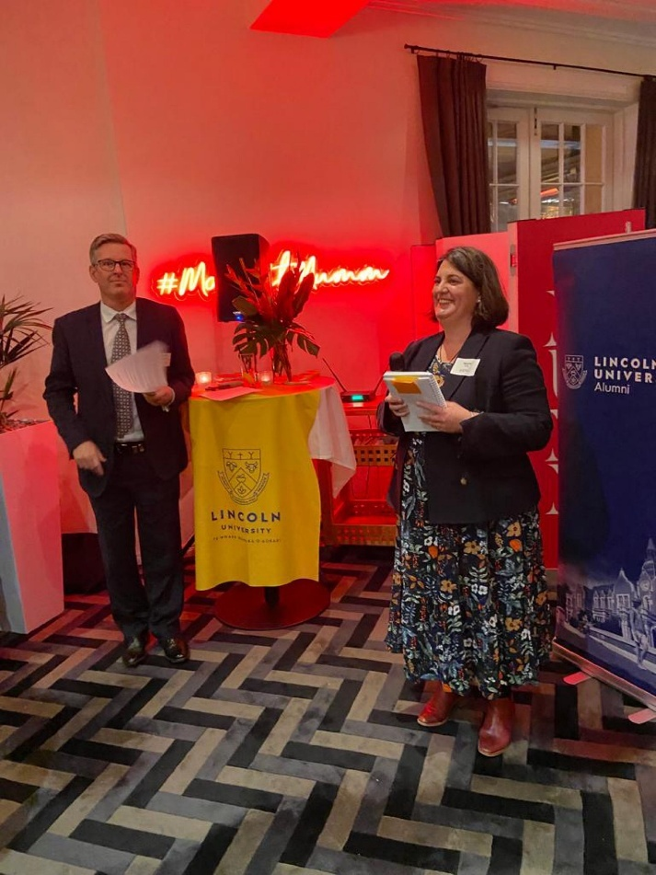
Photo: Damian Lodge and Naomi Wilde

It was a fabulous opportunity to socialise with fellow Lincoln alumni and friends in Auckland after the last couple of years of covid affected in-person events. We had a great range of Lincoln past and present students - from alumni who were at Lincoln in the 1950s, to a current student who was on his term break. We were also very lucky to have an alumnus who travelled all the way from Borneo and was very pleased to be able to attend the event while they were in Auckland.
The LincUp events are a great way for Lincoln alumni to reconnect with each other and with the university, as well as enjoy fantastic hospitality in venues around New Zealand. The Alumni and Development team is planning more events and will keep you updated about future dates and venues as we lock in details.
Thank you to all who attended, and especially those who helped with sourcing the venue and spreading the word to Lincoln alumni in and around Auckland. See the Lincoln Alumni Facebook page and the Lincoln University Alumni website for more photos.


